Text Adventure Game

1. Creating classes
2. 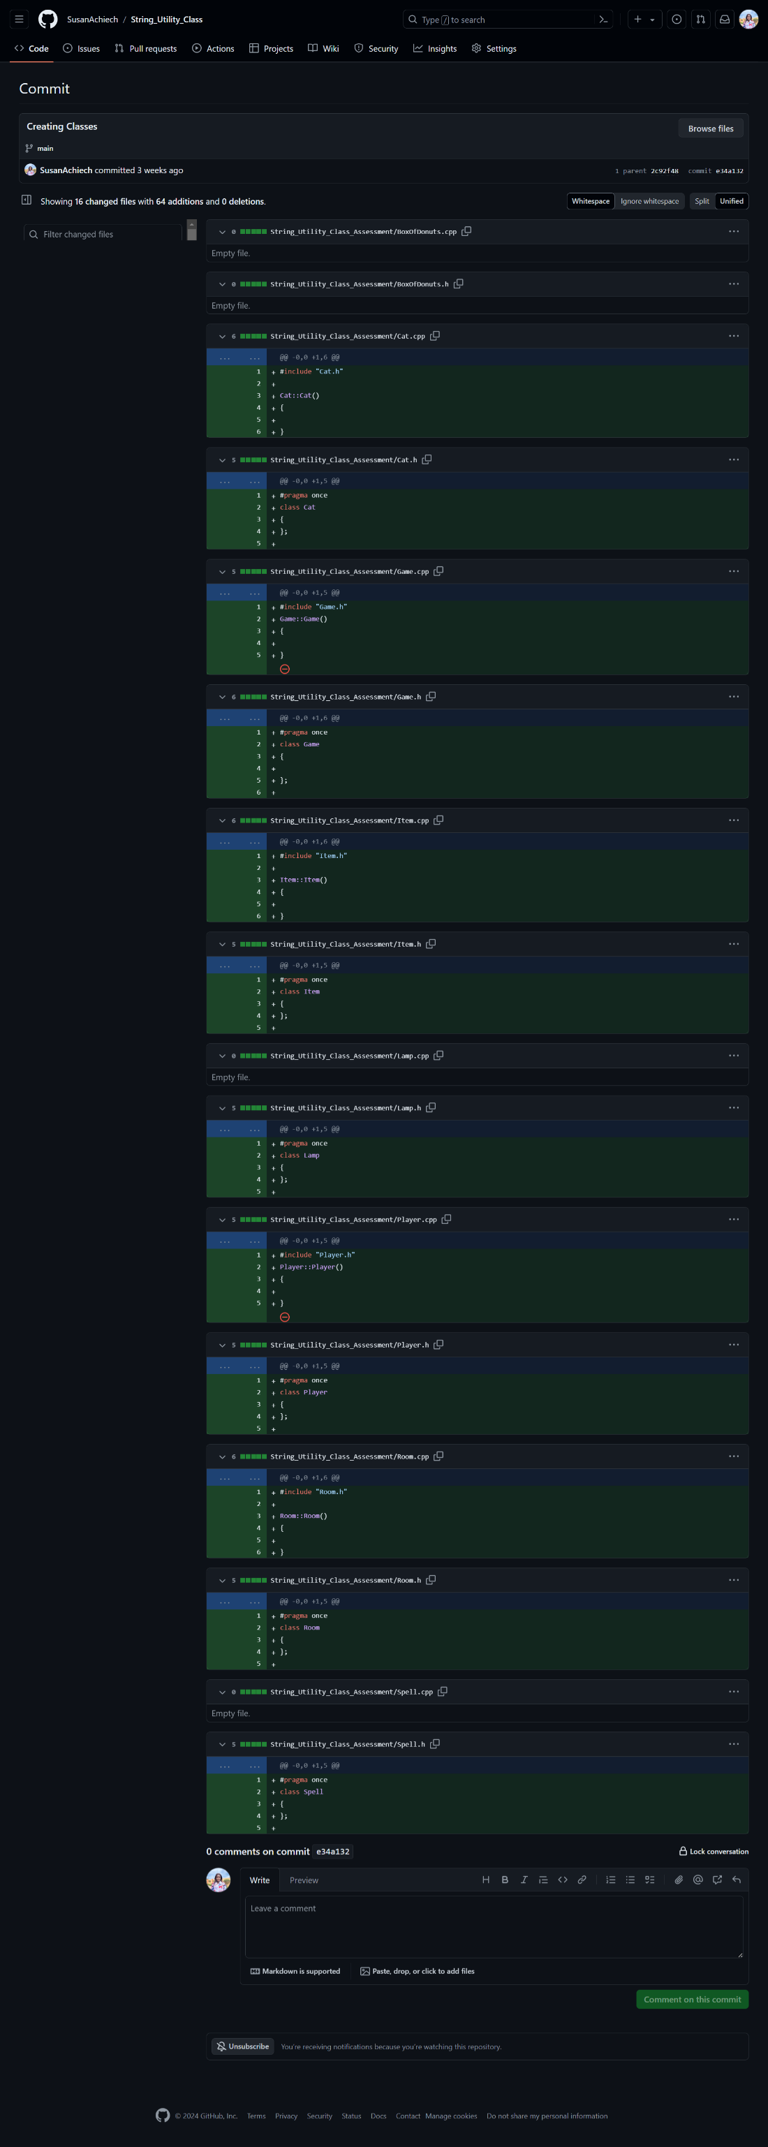
3. Override and use functions in the boxofdonuts.h

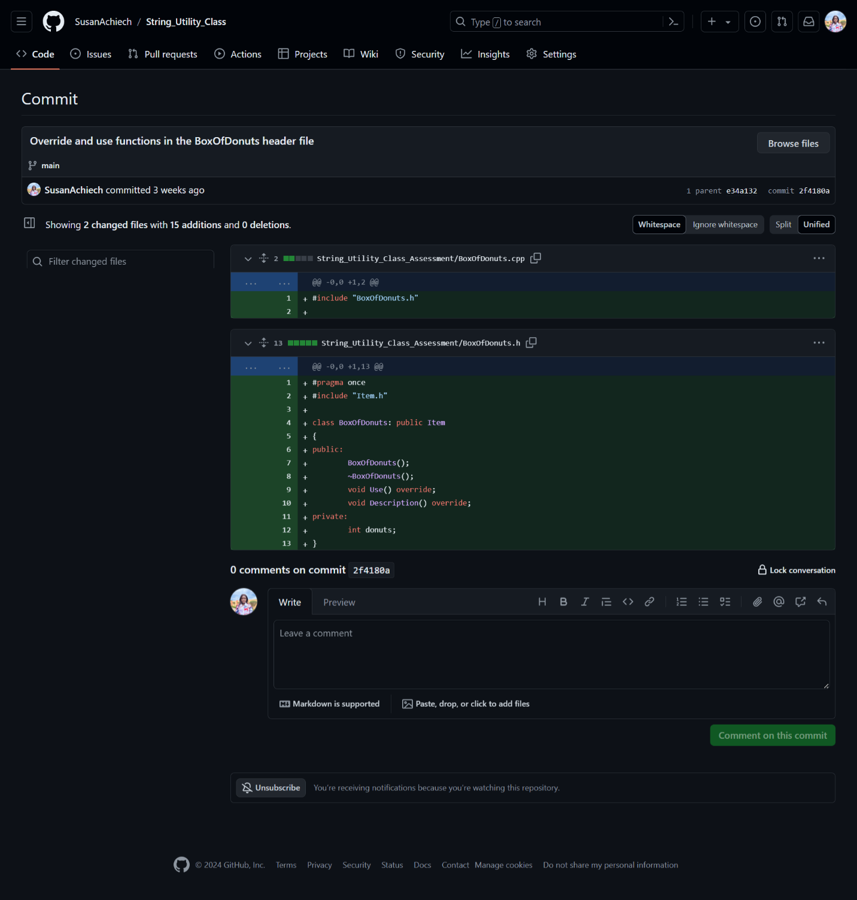

1. Adding override functions to cat.h

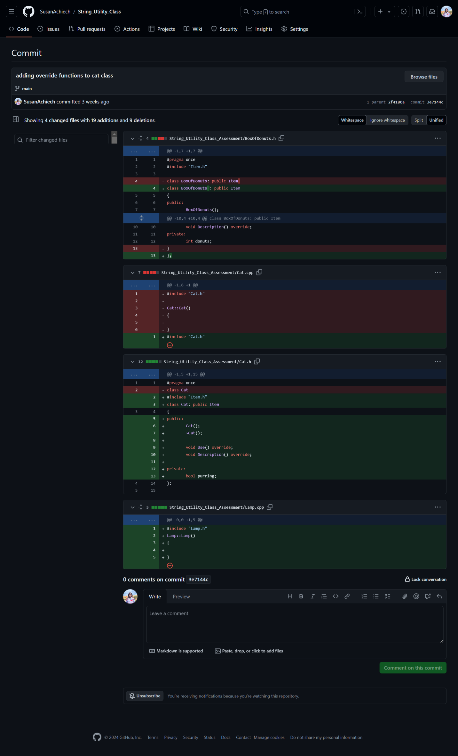

1. Initiating override function in lamp class

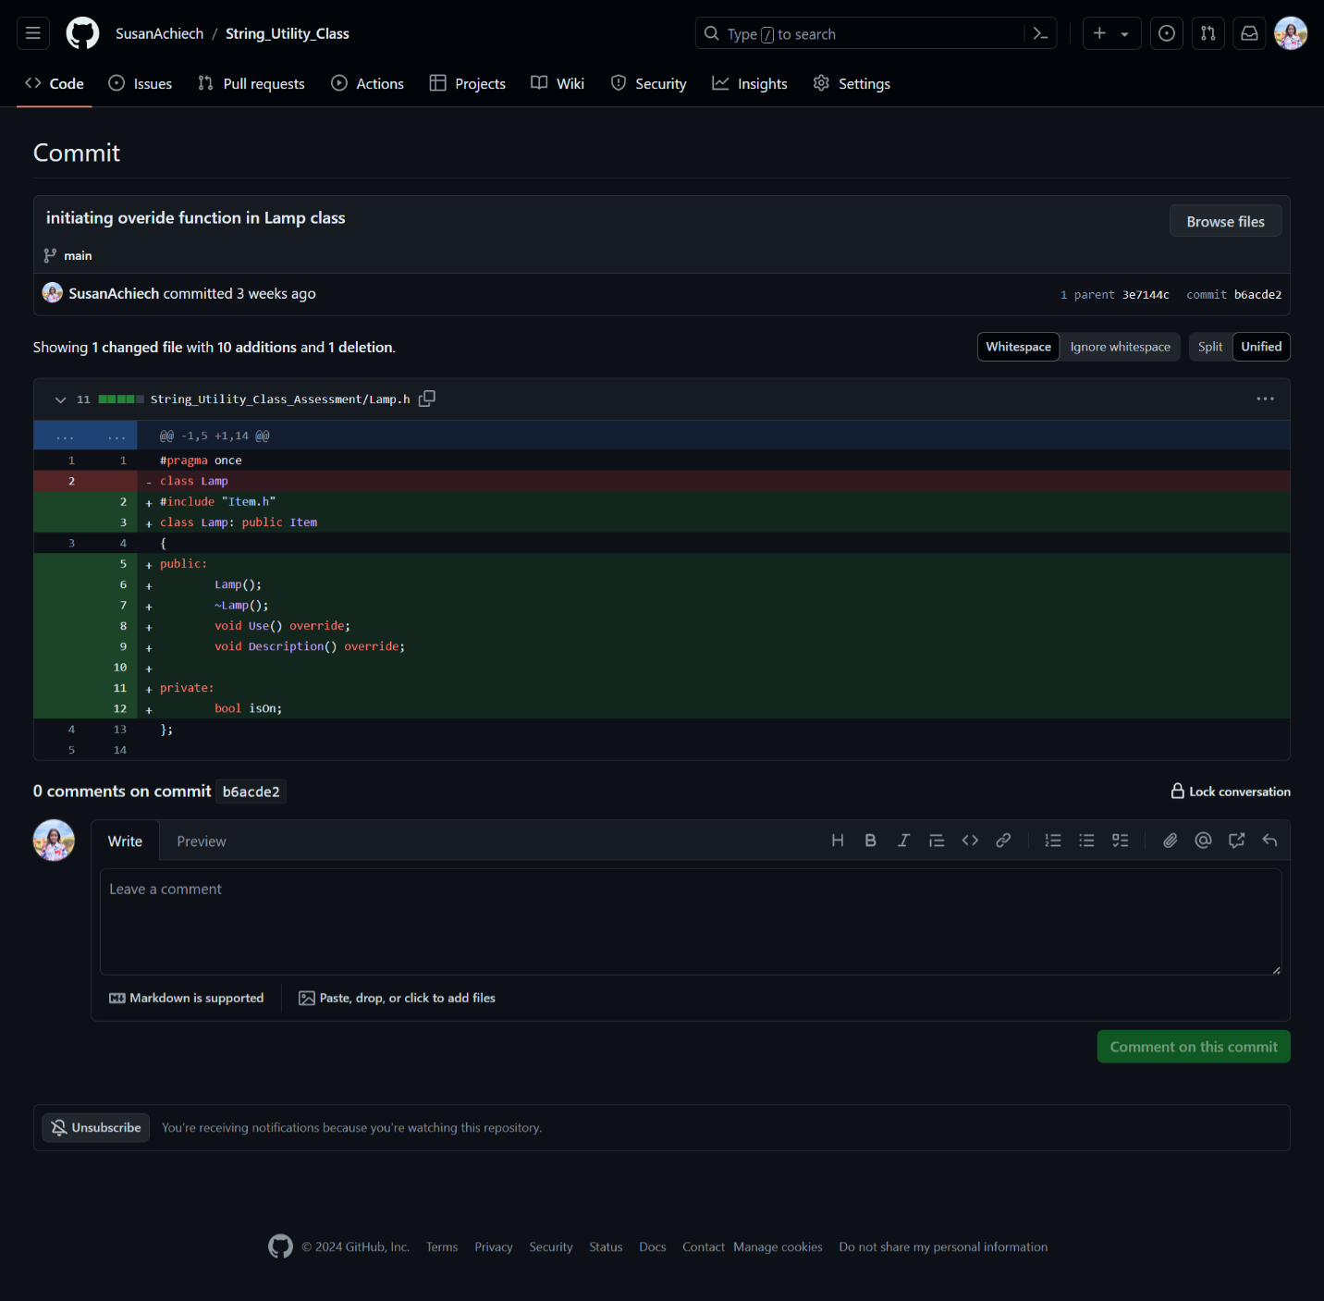

1. Initializing functions in game, player, room and spell files

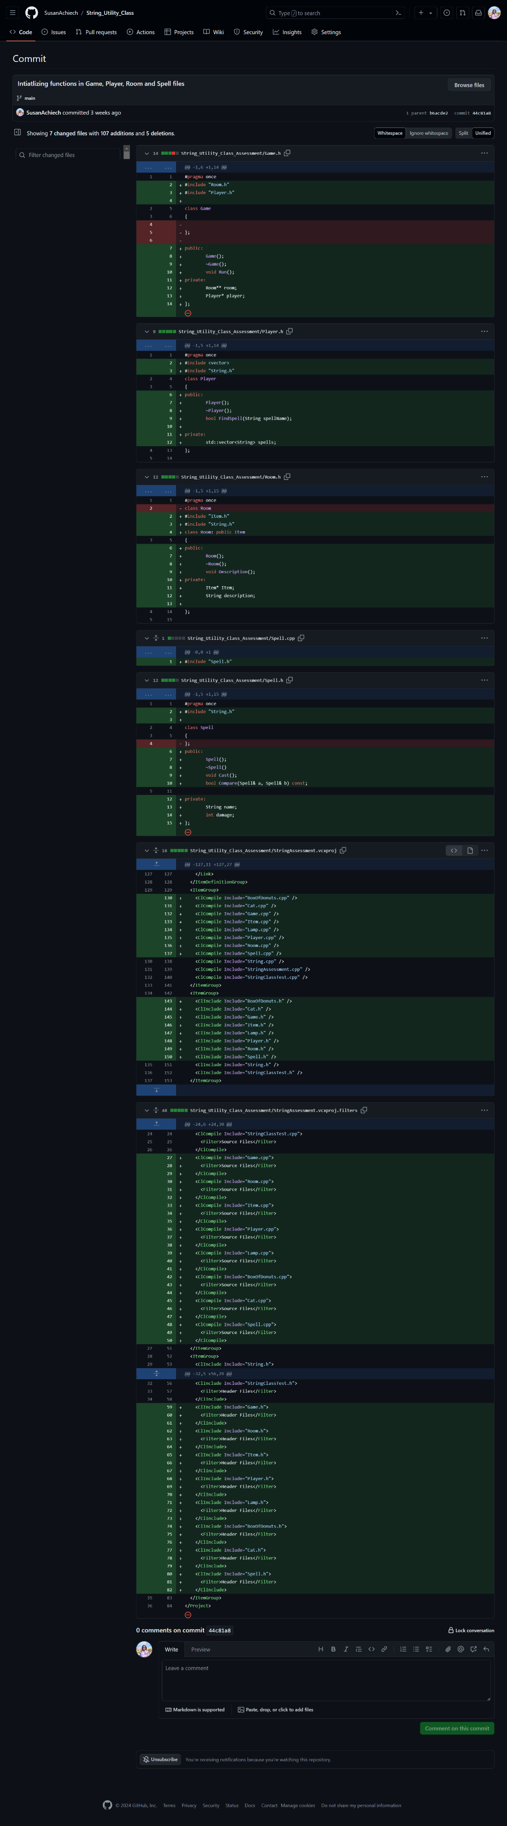

1. Checking number of donuts left

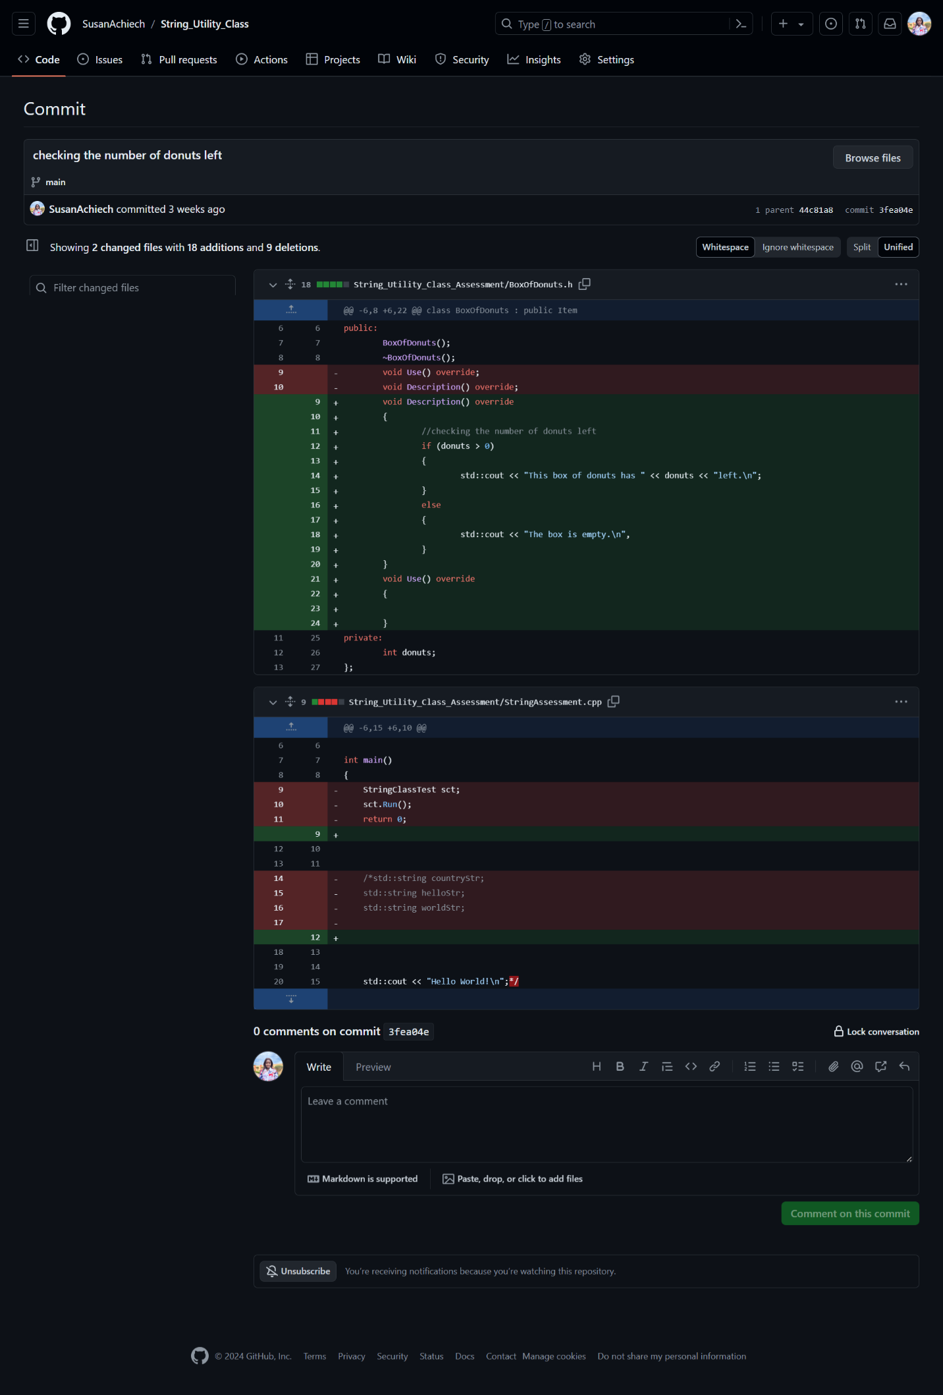

1. Checking if the remaining number of donuts have been eated

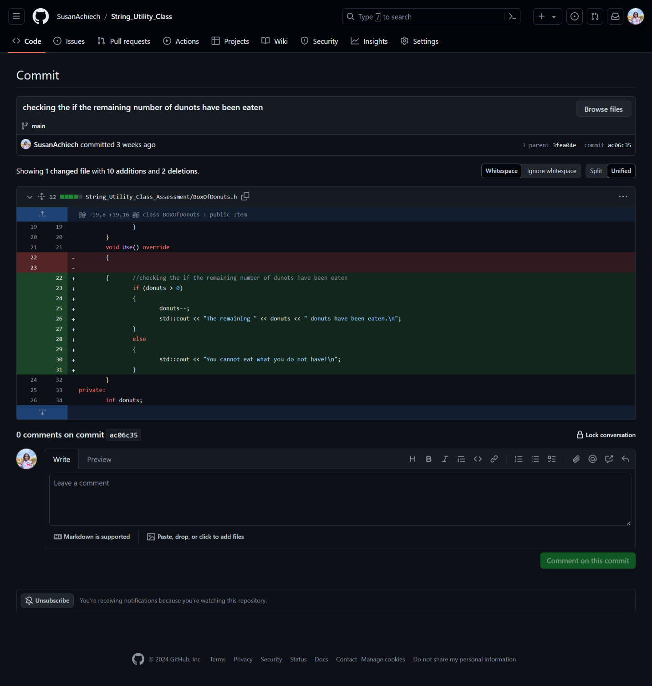

1. Initialization of the item descriptions in the room and checking the items and returning pointer

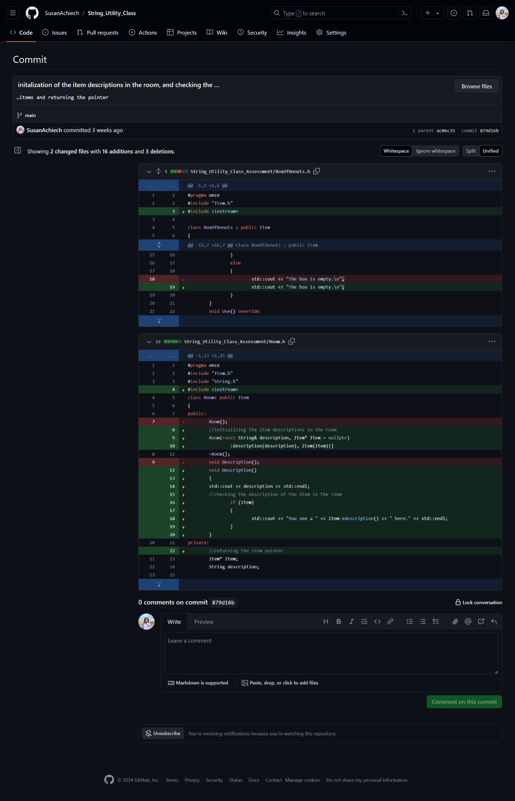

1. Creating an array of spells and checking if the player knows the spell

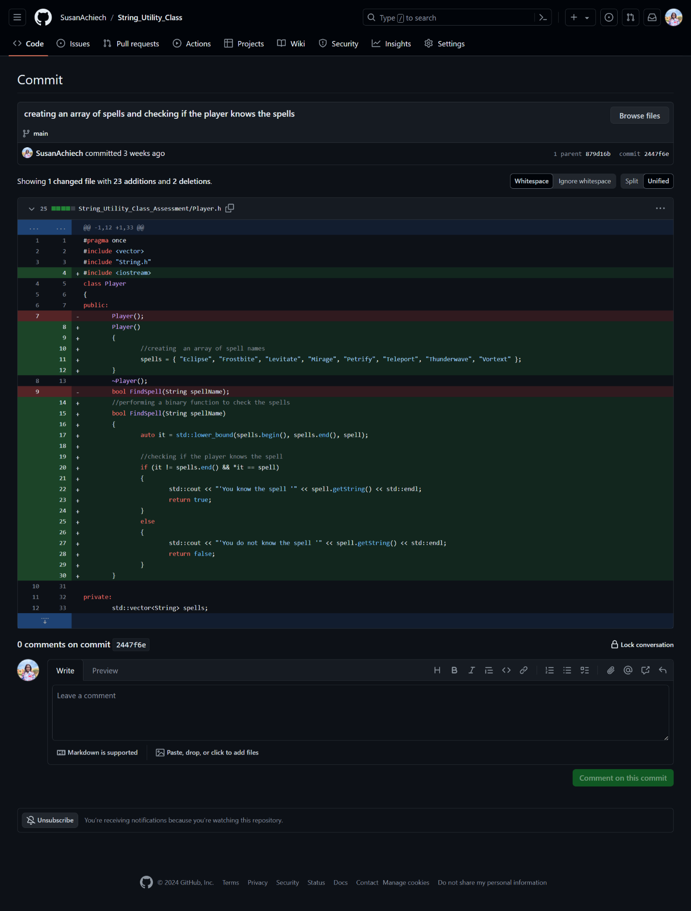

1. Item class initialization

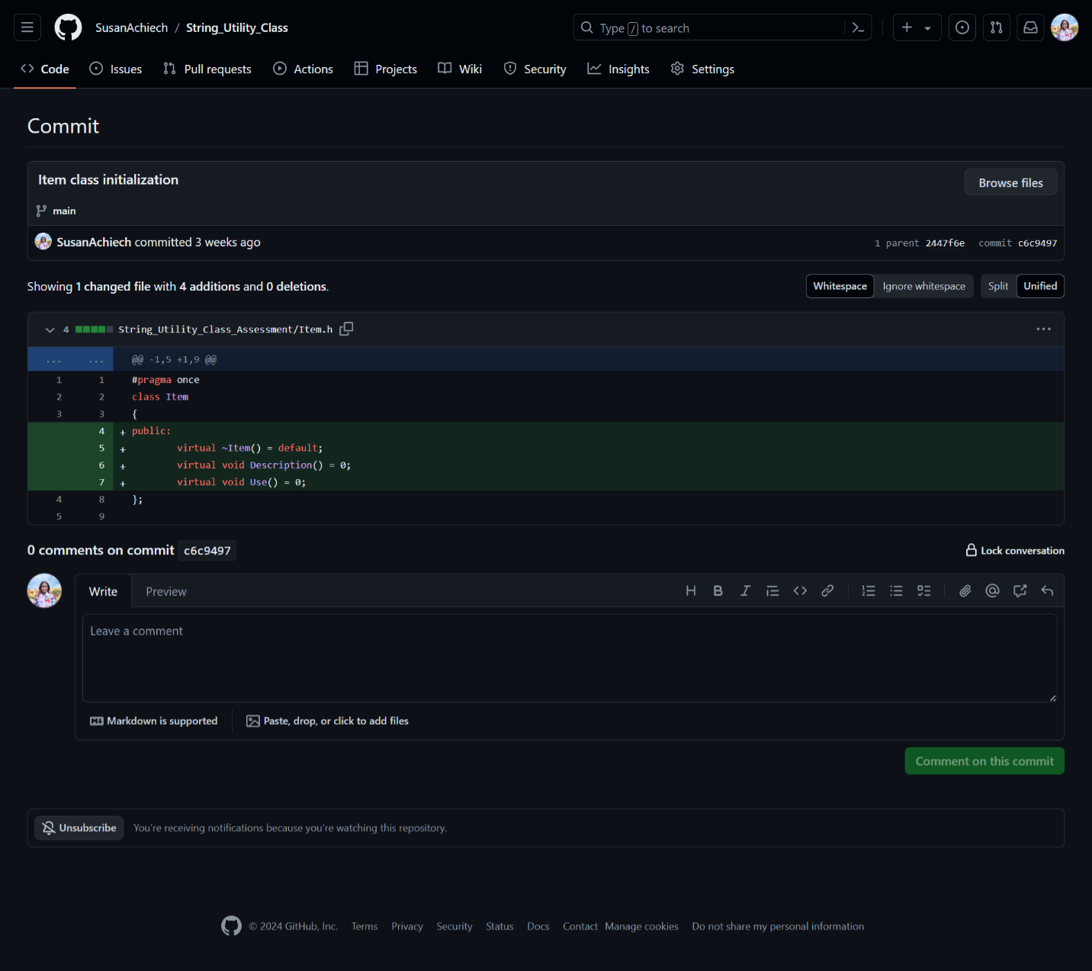

1. Updating the spell.h file

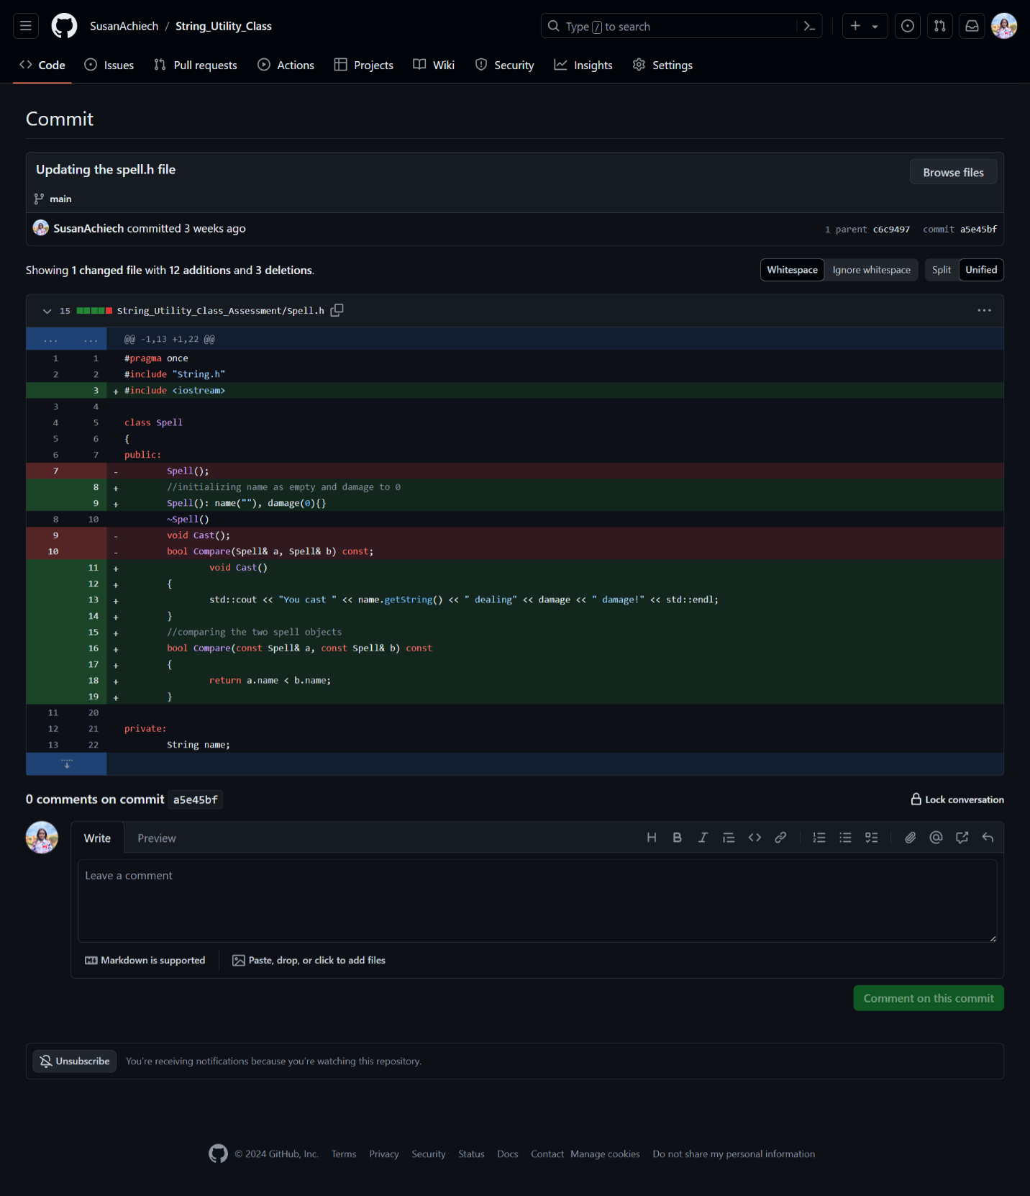

1. Game initialization and deleting player memory run function

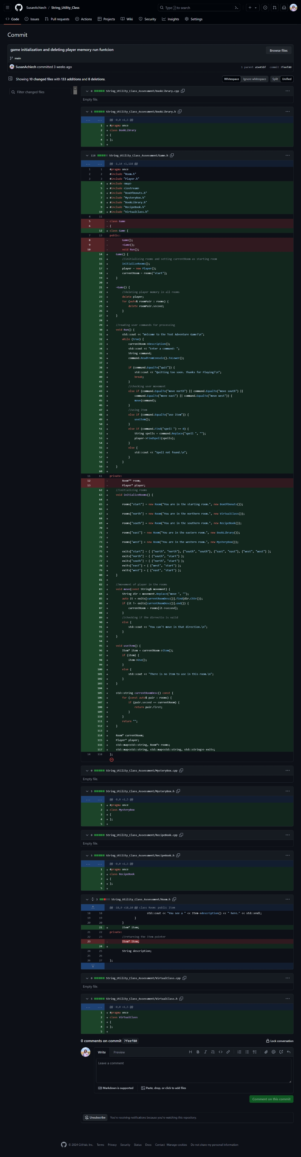

1. Game.h and cat.h files initialization

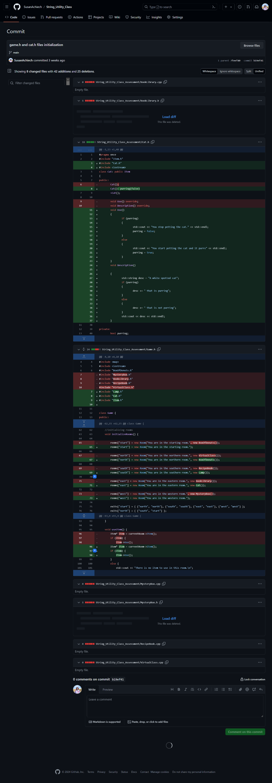

1. Debug and initializing int main

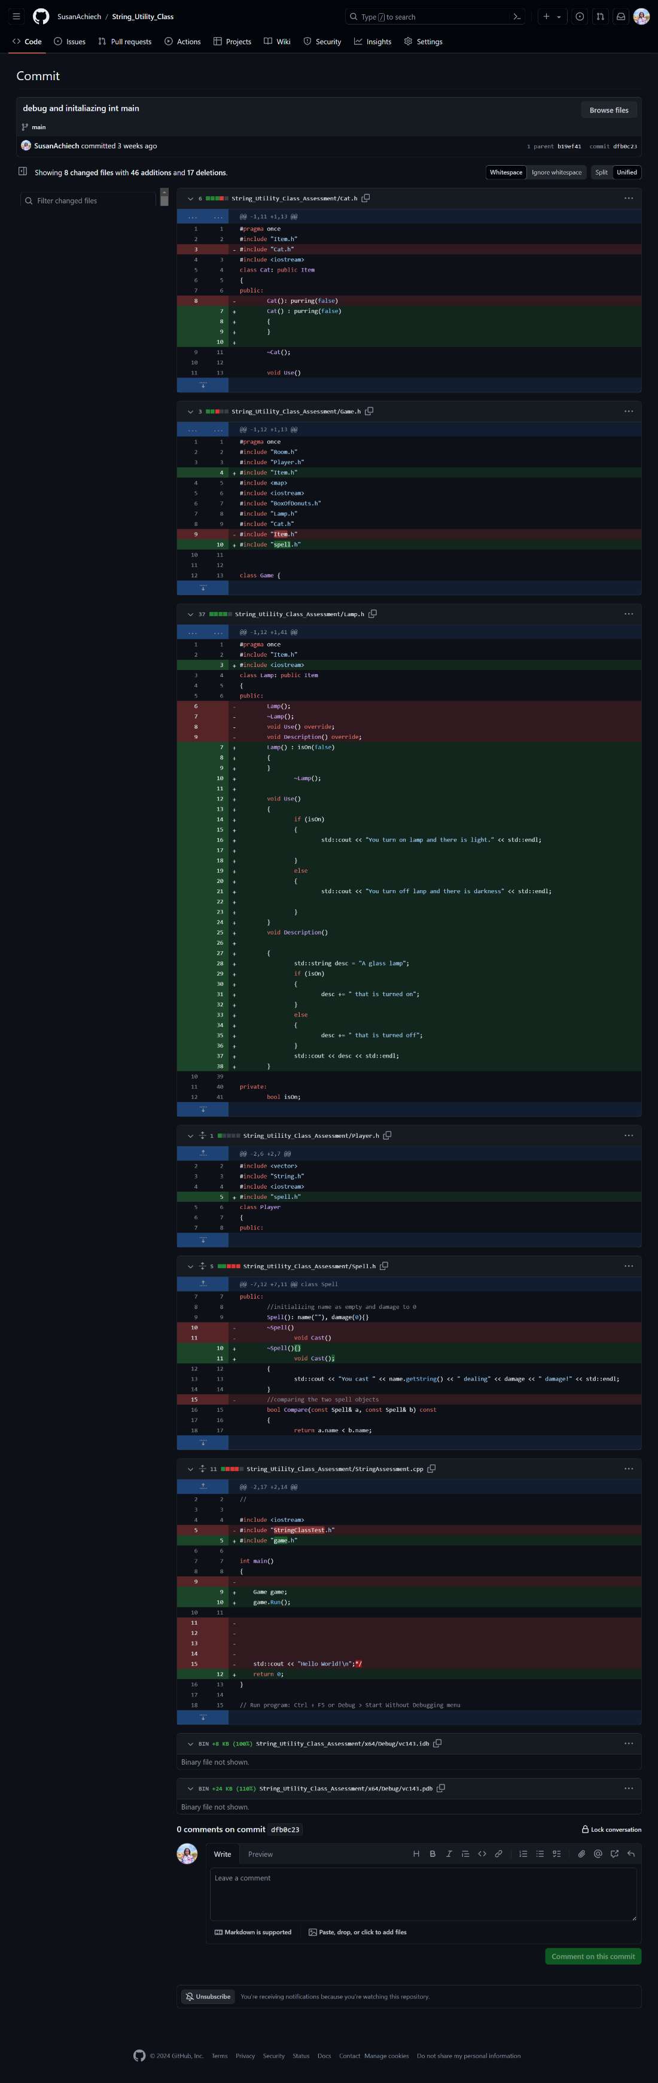

1. Debuging player.h

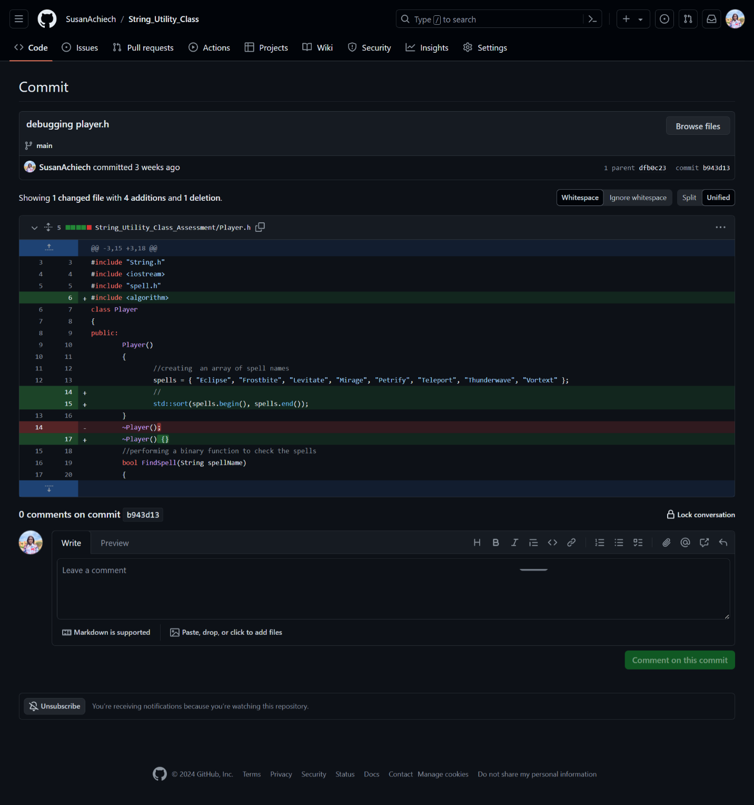

1. Transferring the code from cat header files to cpp file

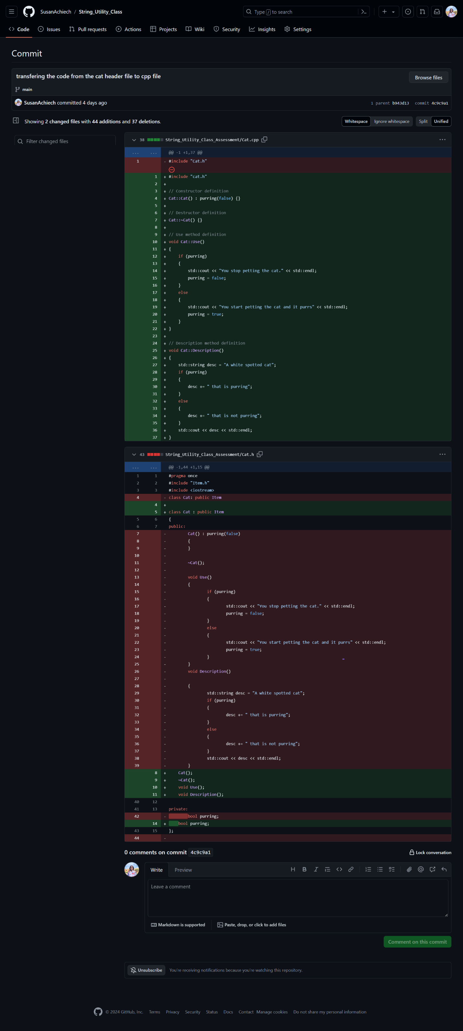

1. Transferring the code from boxofdonuts header files to cpp file

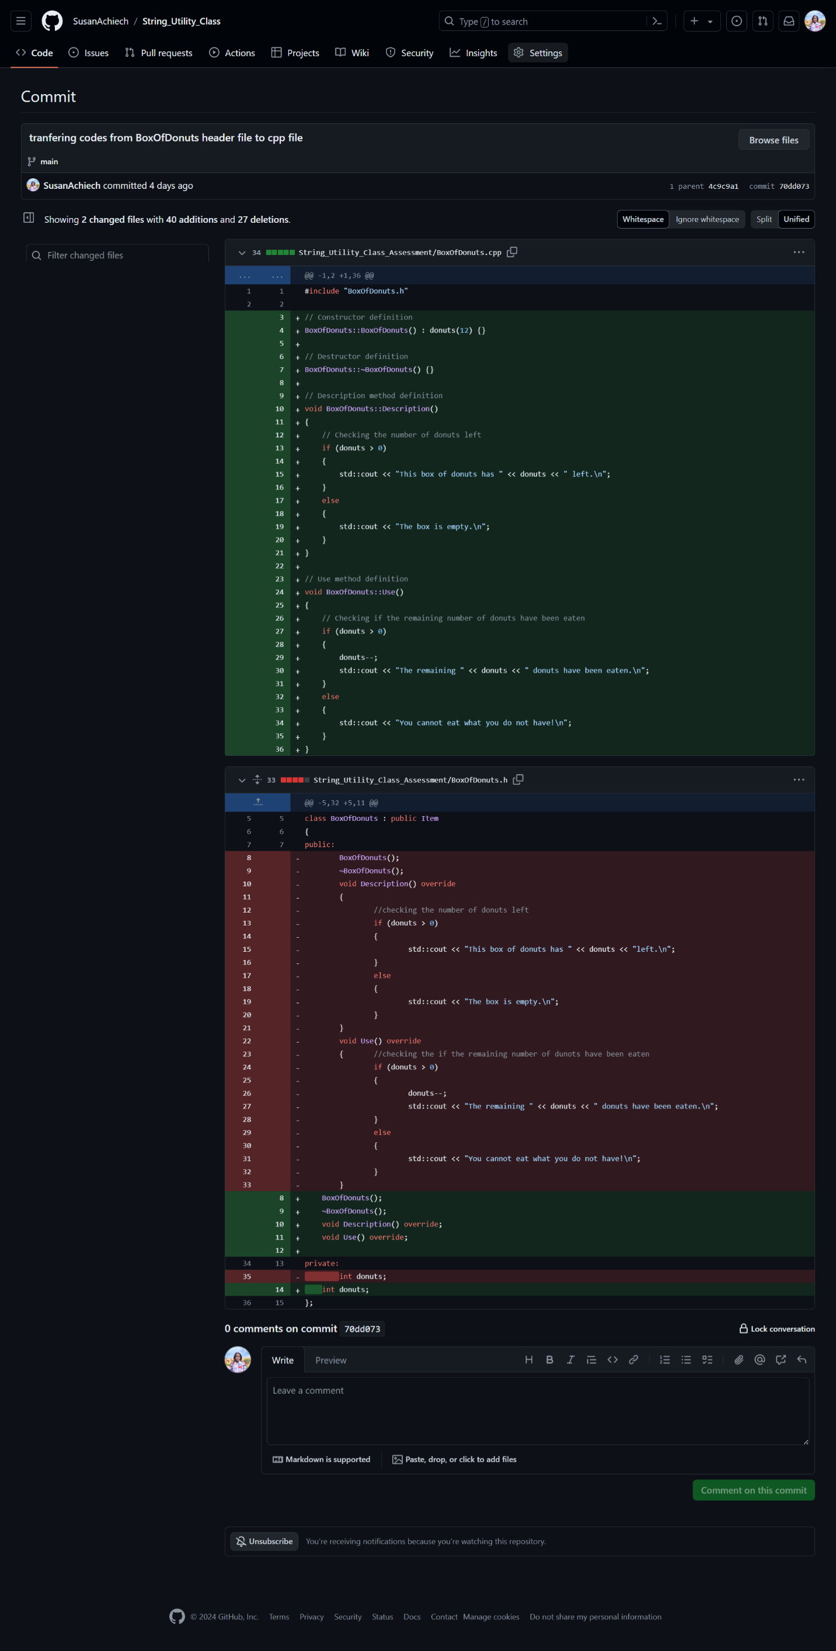

1. Game.h to game.cpp

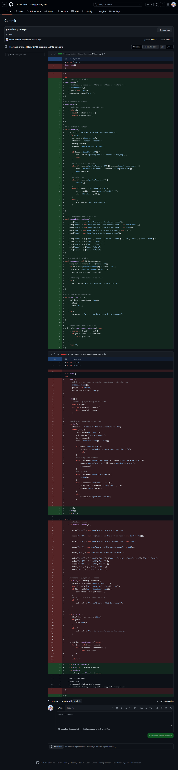

1. Lamp.h to lamp.cpp

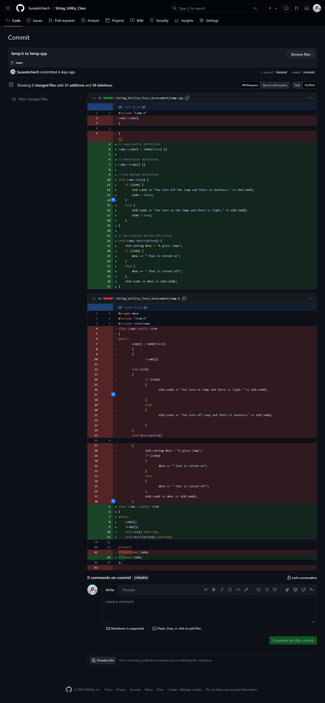

1. Player.h to player.cpp

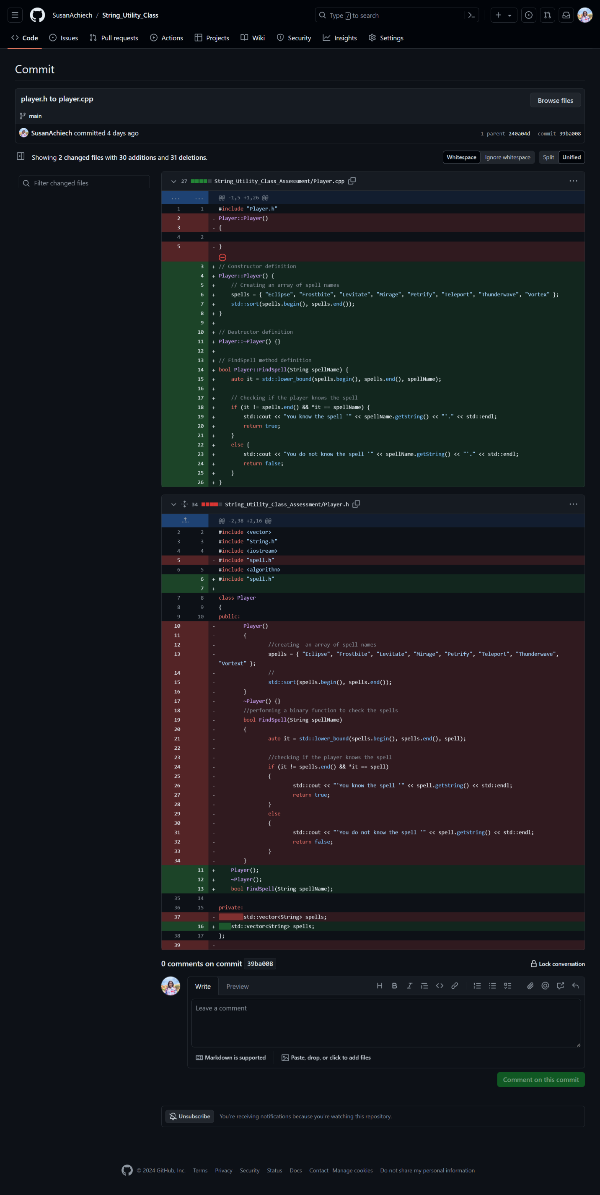

1. Room.h to room.cpp

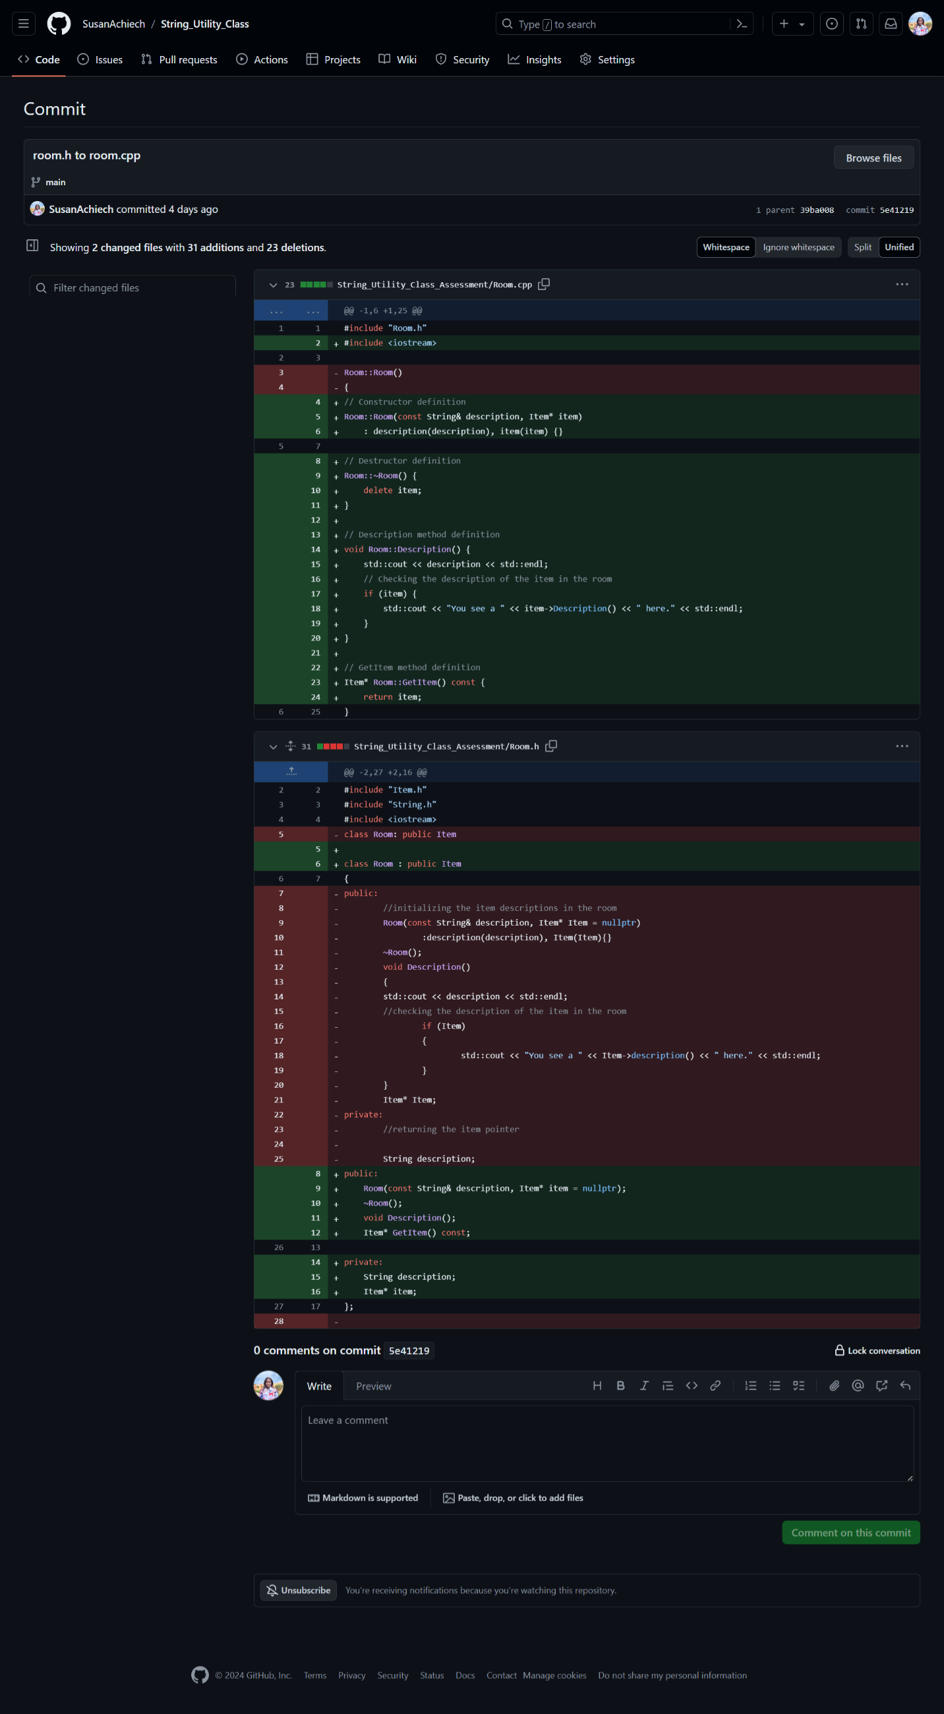

1. Removing codes from header files to source files and debugging



1. Debugging the run function and obj files



1. Debugging the string.h file

